Living under communism
DANA FAINA WATERS·SUNDAY, OCTOBER 25, 2020·READING TIME: 14 MINUTES
Has anyone wondered what it was like to live in a socialist/communist country?
I was born in a God fearing, hard working and loving middle class family in a small village of the region called Transylvania, Romania, in 1965, the year Nicolae Ceausescu came to power. I was the oldest of 5 kids.
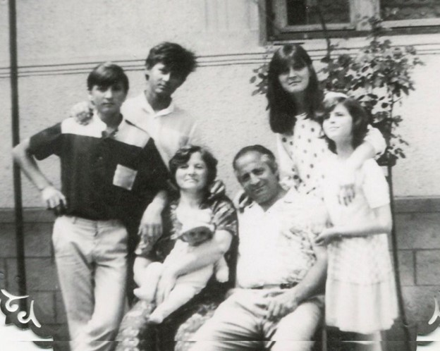
My family, year 1988.
Looking back, one of the things that stands out the most is how isolated we were as a country, living behind the “iron curtain”. The country was closed, people weren’t allowed to travel outside, all the information we were exposed to was censored by the communist government. Leaving the country was a far-away dream for most and those who tried it, risked many years of prison and torture. We had only one TV channel, most of it communist propaganda. They wanted us to believe that we lived in a “paradise world”. And people were threatened for simply whispering their unhappiness.
Before communists came to power, Romania was considered one of the richest European nations. In fact, in 1938, it was called “the bread basket” of Europe.
But things changed in 1945 when they took over and gradually devastated the economy.
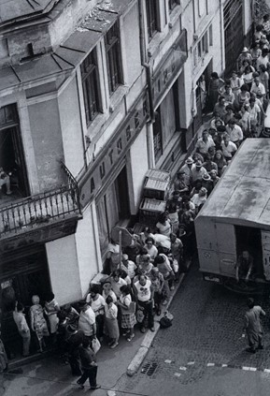
Food rationing was introduced on a wide scale and then promoted it as “a means to reduce obesity” and “healthy eating”. The rations were made smaller every year: half kilo of sugar, flour, rice and half liter of oil, per person per month. It was never enough. Meat was very scarce, mostly on Sundays. I remember waiting in lines, long hours for bread, and many times by the time my turn came, the bread was gone.
Darkness, cold, fear and humility. But in all this, God was so near to sustain, comfort and provide for us.
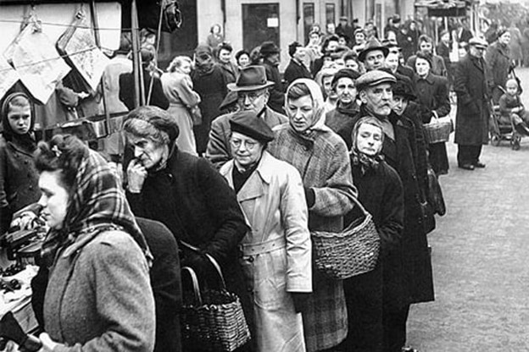
Bread was actually the main food staple for us. Luxury items like chocolate or coffee were impossible to find and so many times the stores had just empty shelves.

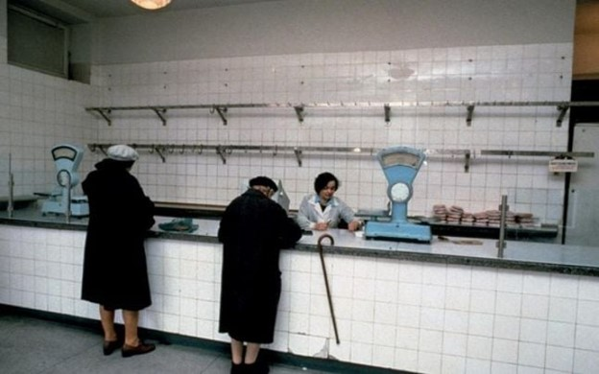
Waiting in line was a way of life. Whenever there would be a line somewhere, people would join and wait, even if they didn’t know what they were waiting for. Just the fact that there was a line meant that something they needed was available for sale.
Political freedom was not allowed, neither was freedom of speech or press. The TV program lasted about 2 hours every day and was full of political propaganda. The media was full of comments about how great and what a genius the dictator was, how the whole nation loved him and how the entire world spun around him. This kind of propaganda was present in school as well, where we were taught songs that glorified him. There were set phrases we were suppose to use when talking about him like: “the genius of the Carpathians”, or “the hero of the heroes”.

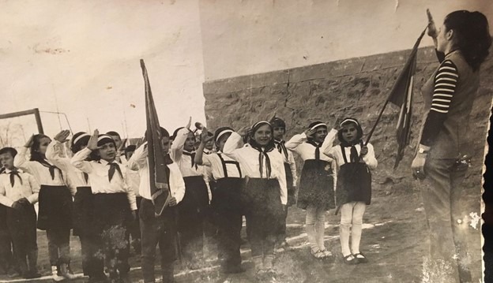
Beginning with elementary school, every morning before classes, we had half an hour indoctrination. Every book or magazine had his picture on the front page, his face was in every one of our classrooms, his eyes watching us since kindergarten.
As believers in Jesus Christ, we were called “repenters” as a mockery name by school mates as well as teachers. We were told we won’t be able to have access to good education because of our faith, high school would be the most.

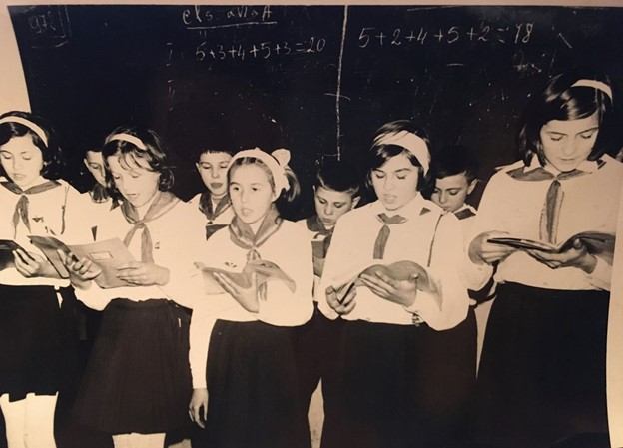
Cultural life was strangled, churches were demolished, history was falsified, books were not available for the reason of hiding the past. To “preserve the energy”. they cut off the electricity from 6 to 8PM across the country. That’s when we needed to the most, so many times I did my homework at candle light. In the cities, people who lived in the apartments had their heating rationed and they would bundle up all day and even go to bed in their warm clothes. The same with the water, people had to save up water in containers, to use later for washing, cleaning or for the toilet. The warm water was available only a couple of hours in the weekends. That’s when everyone rushed to wash up.
The dictator created a personality cult in the 70s and 80s. Newspapers had to mention his name many times on every page, factory workers spent months rehearsing dance routines dressed as soldiers and gymnasts for huge shows at which thousands of citizens were lined up to form the words: Nicolae Ceausescu with their bodies.

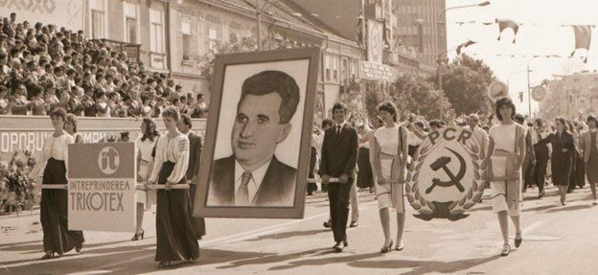

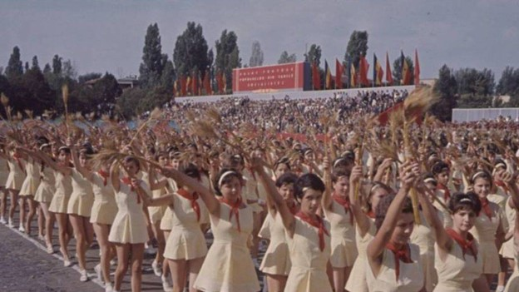

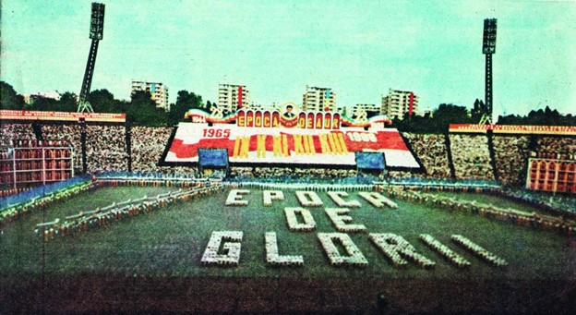
They stole our colors, our dreams, our freedom, but they could never steal our faith in God. It actually grew stronger!
The communists tried to do away with anything that has to do with God from the culture. The first time I heard the word : ”God” on TV was after the regime fell. Not only that, but they taught people to despise God and to look down on Christians. They made it seem like to be a Christian was equivalent to being uneducated, unintelligent, sone kind of sub-human.
In order to impose allegiance to the communist government, a policy of terror was instituted with secret police called “Securitate” arresting people in the middle of the night. Children in school were encouraged as their patriotic duty to report to teachers what parents discussed at home. There was a constant feeling of fear, tension among people, a sadness in their eyes, the oppression and the assaults to human rights. Anything we said or did could have been heard or seen by someone, a neighbor, a passerby or even a family member, and report it to the authorities. We never knew who could be an informer, so we had to be quiet and whisper all the time.
The “Securitate” encouraged citizens to inform on friends and neighbors whom they suspected of harboring anti-government sentiment. Writers and journalists had it particularly bad, sometimes they’s simply disappear, never to be heard of again. Others tried to free across the border to Hungary. If they were caught, they were tortured or often executed. Political prisoners were sent to a town in northern Romania called Sighet. “The greatest victory of communism”, reads a plaque at the entrance of the museum, “was to create people without a memory - a brainwashed new man unable to remember who he was, what he had, or what he did before communism”.
The Communist Party was set to create a “new man”, a docile, subservient specimen, through fear. Social life was constantly monitored, groups larger than 5 people were not allowed. They controlled everything, even the young men were supposed to have their hair cut short.
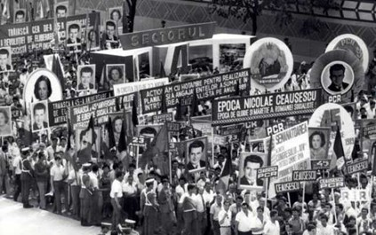
When they introduced collectivization, they tried to convince people to give up their land and possessions. When persuasion failed to convince them, violent means were used. With their possessions, people were stolen their dignity and identity. My grandpa told me how they came and took their precious land and animals and were forced to go labor on their “collectives” for almost nothing.

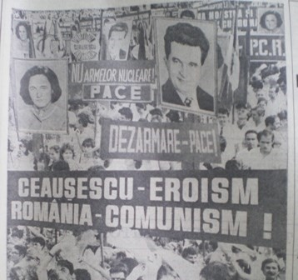

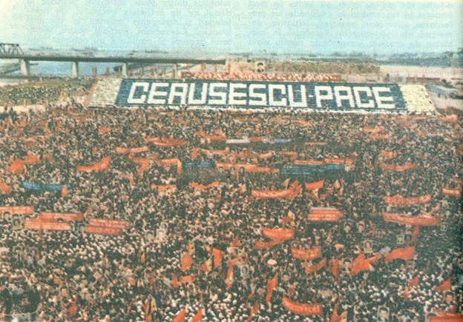
I remember the lack of hygiene items, my mom used to make homemade soap out of leftover pork fat and lye. Every once in a while someone would smuggle some fine soaps that smelled so good and the package was so colorful. We would use it sparingly and even save the package and put it on the shelves for display. I also remember the high school commute by train, the half an hour walk in the complete darkness to the train station. Then getting on the dark and cold train, sitting tight next to each other so we can get some warmth, closing our eyes for the half an hour ride. I remember hiding the prohibited christian books by writers like C.S Lewis or Joni Eareckson. We would often copy entire passages or the whole book in notebooks because we were so hungry for hope and truth. I remember hearing the communist elite feeding their kids with bananas, while I’ve never seen one, or hearing them talk about using a small cube of butter to polish their shoes, while butter was such a rare luxury for us. Or the appealing smell of oranges, only at Christmas. We would open one and each have one or 2 slices.
After the regime fell, western countries came to help and brought trucks with goods like clothing, hygiene items, some food items. Holland was one of them and a particular family became so close to us. In 1992 they invited my sister Lavinia and I to go to Holland for 2 weeks. I was so excited, it would be my first travel outside of our closed grey universe. I was amazed to see so much color, so much abundance. In a grocery store, seeing all that food on the shelves, I burst in tears. I kept a journal, writing everything I’ve seen and done and I have it to this day. I am so grateful to Hofman family for their sacrificial love for us in those dark years of our lives.
The only way to find the truth about what was going on in the world or in the country was Radio Free Europe, which was illegal. We would gather the whole family and listen quietly, at night. Hearing Christian songs and the Bible proclaimed on the radio was so new and refreshing! My dad had us kids sit quietly and take notes. There was a pastor, Iosif Ton, who was forced to leave the country because he was too vocal in his christian faith. He would be on Radio Free Europe, giving messages of hope and encouragement for us all, telling us to remain strong, because God will deliver us from oppression, soon. I will never forget the spark of hope that was ignited in my heart and the eagerness to listen more. I still have the notebook full of his messages of hope! And yes, soon enough, God brought down the communism with a loud crash.
It all started in December 16, 1989 in Timisoara, where some very brave young men dared to take the streets and ask for freedom. The unrest soon spread throughout the country, fueled by the news that protesters were being gunned down by secret police.

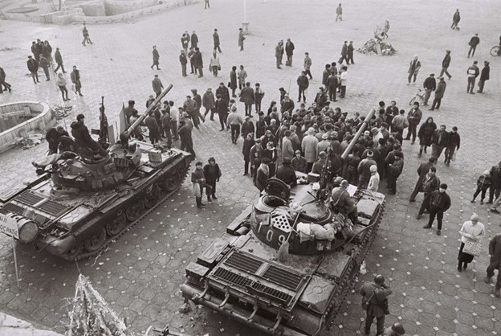

The dictator, returning from an oversees trip with his wife, tried to quell the growing chaos in a speech from his balcony in Bucharest, on December 21. As he looked out over the usual mass of compulsory adoration - the people in neat rows bearing Marxist slogans and his portraits - the aging despot had hardly begun to speak before he was interrupted by a growing chorus of boos, whistles and shrieks. It was both unprecedented and unthinkable. TV cameras momentarily broadcast Ceausescu’s astonished face live across the nation, before quickly cutting away. For the first time, people had seen his vulnerability. It was the beginning of the end.
https://youtu.be/t6pvMFfQF50 (Excerpt from Ceausescu’s last speech). It still gives me chills.
For the first time in their lives, Romanians shouted their secret dreams aloud: ”Liberty! Freedom!” Then started singing a patriotic song that was banned before: “Awake, Romania!”
As the night fell, someone began shouting: “Down with communism! Down with the tyrant!”

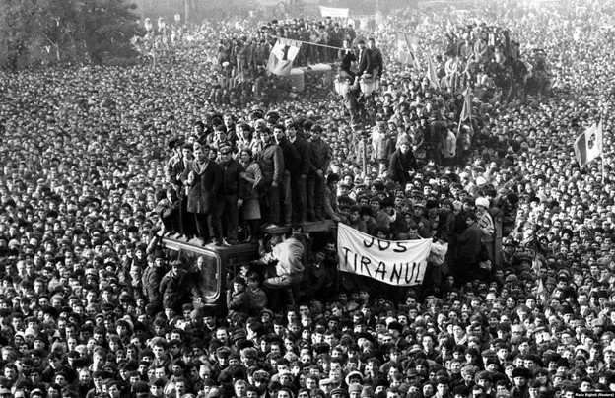
The communists responded with the brute force and ordered their troops to open fire on the protestors. Over 1.000 people were killed and 3.000 wounded.
The dictator and his wife managed to flee, but were captured and on Christmas Day - a holiday that had long been suppressed by Ceausescu’s atheist regime - they were executed.
It was a bloody Christmas, because some brave young men and women stood tall and decided that enough is enough! But it was our fist Christmas in freedom!

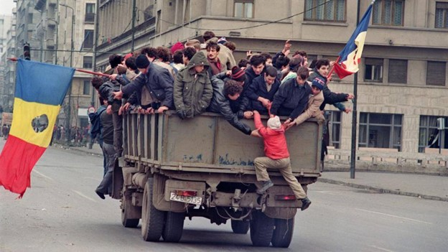

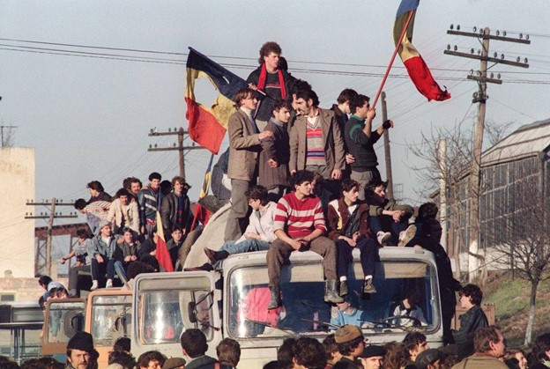
I can remember the euphoria of the thought of being finally free! I can’t accurately describe it, it was incredible! But we had no idea how long it will take to rebuild the country so ruined by the oppressive totalitarian regime. To this day, the country still bears the seen and unseen scars. I can’t even imagine someone thinking that socialism is not bad, or that is not communism. The marxist ideology promises specific virtues, but it delivers the opposite. (No communist comes to power promising bread lines and prison camps). But the result is human suffering that should grieve anyone.
Here are 3 major truths about marxism.

Marxism promises belonging but delivers isolation.
The desire to belong to something larger than yourself is universally human and marxism appeals to this desire by preaching collectivization and that they’ll all share in the common good. But what they delivered was a total destruction. not only did they bulldoze villages, forcefully relocating peasants to miserable block apartments, but they also bulldozed people’s sense of trust and reliance upon each other. Spies and informants infiltrated nearly every relationship and every gathering. Those willing to denounce their close friends and family earned special favors.

Marxism promises equality but delivers scarcity for everyone but the elites.

It is an ideology of envy. Anyone who has more than I do is clearly taking something from me. Government should ensure that we’re all equal. If all citizens were equal under communism, they were equally impoverished. and while Romanians came close to the brink of starvation, Ceausescu built himself the largest palace in the world, grotesque and opulent. It was from the balcony of this palace that he delivered his final speech, laced with tributes to to socialism and “the working people”. this is the hypocrisy that marxism never fails to deliver.

Marxism promises dignity and compassion but delivers degradation and cruelty.
Everywhere communism has reared its head, it portrays itself as an advocate for the worker, the defender of the common man against the “greedy rich”. But in reality, it fosters nothing but cruelty, selfishness and lack of empathy, the natural and bitter fruit of an ideology that isolates people from each other, casting them as rivals for the same scarce goods.

Marxism vs. Communism vs. Socialism
Marxism encompasses both socialism and communism. Romania was a socialist country: Socialist Republic of Romania. If you watched Ceausescu’s final words, I counted a total of eight mentions of “socialism” or “socialist Romania”. If any of my American friends believe that socialism is harmless, humane and compassionate, please, look at the facts. I have witnessed and experienced the ugliness, the darkness, the poverty, the isolation, the despair it leaves behind, that's the evil legacy of communism. Believe me, you don’t want it here in America! Pray to God it never comes!
“Socialism is the philosophy of failure, the creed of ignorance and the gospel of envy. Its inherent virtue is the equal sharing of misery” Winston Churchill

