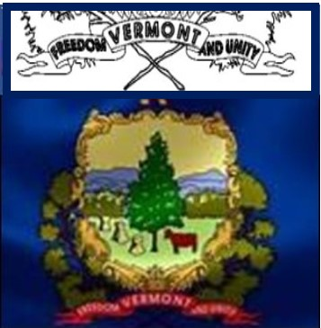
FREEDOM & UNITY
SPIRIT WEEK

Get your student councils to select a week perhaps leading up to Valentine’s or President’s Day and come up with a Spirit Week Theme for each day – (Suggestions below to help prime the pump)

Use your Head & Heart - Hat & Hearts Day – ball caps, 3 corner hats
Contstitutional Rights are in our country’s Jeans – Jeans Day
Fulfill you’re your dreams and support each other – PJ Day and bring a canned/boxed food for foodshelf
Truth is Marching On Day – Unique Footwear Day - Wear boots/slippers/tye die/ footwear
Our Future is Bright – Wear sunglasses
RWB Day – Wear Patriotic attire
Constitutional Rights Day – know the themes of these rights and pick your own attire to depict it.

