AMERICANISM AND MARXISM
A SYMPOSIUM

Part 1-
Definitions and Characteristics of Americanism and Marxism!

Segment goals for participants:
1. Be able to state concise, accurate and useful definitions for Americanism and Marxism.
2. Be able to name 3 tenets for each world view.

How to recognize each system! Basic definitions. Tenets of each one.

World view: total philosophy, not just economic or political!

2 World views: philosophy, (more than political stance or economic theory), also spiritually animated. Everyone is on a spectrum between these two world views.

POLES- People fall on a spectrum between these two centers of thought!
Very few people score perfectly in either camp!

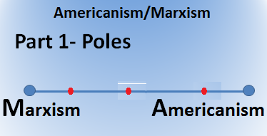

AMERICANISM:
The Judeo-Christian world view on which the United States was founded.

Characteristics , Tenets and features of Americanism:
1. Ultimate reality:
The Kingdom of God temporarily being challenged by the kingdom of Satan!
(In God We Trust!)

2. Morality: Judeo-Christian Biblical standards including the 10 commandments, equality of all people, marriage and other institutions created by God.

3. Healthy society consists of multiple institutions all under God! (Family, Church, Enterprise, Government)(Other major institutions should be independent of government)

4. Individual freedom- religion, speech, press, assembly, petition. People are eternal spiritual beings temporarily living in physical bodies on earth.

5. Individual expression, art- reflect the real beauty of God and creation.

6. Government of, by and for the people (self-government)
Distrust of centralized power: this corrupts and enslaves
Political diversity is natural and should be respected
(Limited government)

7. Order and cooperation lead to progress and prosperity (free decisions). (Free enterprise)

8. Free exchange of ideas and view points

9. Minimum number of laws (strictly and impartially enforced)(Trial by Jury)

10. Freedom of individual citizens to keep and bear arms!

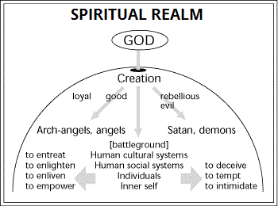

MARXISM:
An atheistic world view that relies on human conflict to accomplish socioeconomic progress.

Characteristics, Tenets and features of Marxism:

1. Ultimate reality: The physical universe! (Atheism!)
(Religious faith is insanity)

2. Morality: Whatever advances revolution, “equity” according to the Party.

(Lying, cheating, deception are all OK when these further the cause.)

3. Healthy society is equity between all citizens. (Economic determinism!)
(Dialectic: thesis, antithesis > synthesis)

4. Individual freedom- highly restricted to whatever the Party deems good for society, wealth transfer. People are advanced animals. No life after physical death.

5. Individual expression, art- must support the revolution!

Dark, demonic products

6. Government of, by and for the Revolutionary Party.
(Socialism- government control of economy and much else.)
(All other institutions are to be subservient or eliminated)

7. Progress and prosperity result from conflict between oppressed and oppressors.
(Constant revolution, chaos, conflict are key to progress)

8. No Free exchange of ideas and view points. Opposition must be demonized, crushed and eliminated Government thought control- Totalitarianism.

9. Profuse number of totalitarian laws (selectively enforced)(Secret rigged trials)

10. Only the state can keep and bear arms!

