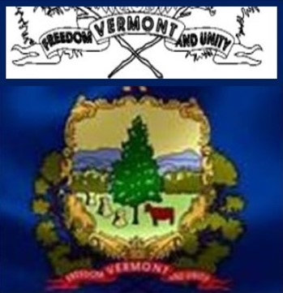
FREEDOM & UNITY
Essay and Poster upto 4th grade
Essay OR Podcast upto12 grade
CONTEST
Protecting Our Freedom & Unity
Sponsored by Advocates for Vermont and Vermonters for Vermont
SUBMITTING ENTRIES - Students must digitally submit their entries along with a jpeg picture of a completed, parent signed registration form, in Jpeg or PDF formats by President’s Day, Feb. 21, 2022 to AMAVT22@yahoo.com. Schools may want their own judges to decide which 6 entries will be submitted by their school. A list of other unsubmitted entries may also be submitted and used to evaluate schools for their broad based participation (see details below.)

JUDGING - A panel of 5 judges for each category, working remotely from each other will be used. They will represent diverse backgrounds – teaching, farming, parenting, business, art, law enforcement, government, and other professional backgrounds. Identity codes for schools and participants, will be on the entries when given to the judges. Judges will not know what town, school, or names. They will make comments and determine points to each entry. Their first choice will get 5 points, 2nd 3 points, and honorable mentions will get 1 point. They may give up to 2 additional points at their discretion.

USE OF ENTRIES Entries may be displayed at the State House in some fashion. They will become the property of the event sponsors and may be shared with other media sources. Parent permission must be given before the student’s name will be shared publicly with their entry.

ANNOUNCING WINNERS – Schools will be informed of Winning Entries by April 5. Students will be invited to the State House, date TBA, to receive prizes, have a tour of the State House, if schedules mesh – meet with the Governor and Legislators, and have a tour at the Vermont History Museum. Parents and/or School Staff representatives will be encouraged to join them.

PRIZES - For the Poster + Essay Contest for Elementary Students - First, Second place and Honorary participants will receive $50, $25 and Certificates respectively. For the Essay Contest for up to Eighth Grade Students - First, Second place and Honorary participants will receive $75, $50 and Certificates respectively. For the Podcast Contest for up to Eighth Grade Students - First, Second place and Honorary participants will receive $75, $50 and Certificates respectively. For the Essay Contest for 9-12 Grade Students in - First, Second place and Honorary participants will receive $150, $100 and Certificates respectively. For the Podcast Contest for 9-12 Grade Students in - First, Second place and Honorary participants will receive $150, $100 and Certificates respectively.

Broad Based School Participation - Schools that exhibit broadbased participation will be recognized and be candidates for a portion of a pool of up to $5K to be divided among the schools at the discretion of the judges. Broad based participation points will be given to schools that:
- Have 2+ teachers engaging student participation and submit 4+ entries (2pts)
- Invite a speaker from our speaker’s bureau to address an English/History/Video Arts class. (4pts)
- Have a school assembly with someone from our Speakers Bureau (6 pts)
- Submit a picture display of classrooms engaged in diverse Constitutional Right Themes (6pts)
- Submit a picture display of 10+ entries not submitted beyond the 6 entries that are submitted for the contest. All displayed in public places in your community by April 5. (8 pts)
- Have a Spirit week based on diverse Constitutional Rights Themes (10 pts)

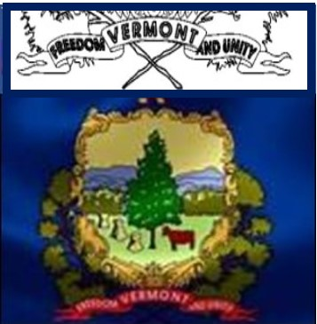
OPTIONAL
FREEDOM & UNITY
SPIRIT WEEK

- Have your student councils to select a week perhaps leading up to Valentine’s or President’s Day and come up with a Spirit Week Theme for each day – (Suggestions below to help prime the pump)
- Use your Head & Heart - Hat & Hearts Day – ball caps, 3 corner hats
- Contstitutional Rights are in our country’s Jeans – Jeans Day
- Fulfill you’re your dreams and support each other – PJ Day and bring a canned/boxed food for foodshelf
- Truth is Marching On Day – Unique Footwear Day - Wear boots/slippers/tye die/ footwear
- Our Future is Bright – Wear sunglasses
- RWB Day – Wear Patriotic attire
- Constitutional Rights Day – know the themes of our rights and pick your own attire to depict it.

