What can we do to address
What’s Wrong with the USA?

What can we do to address
What’s Wrong with the USA?

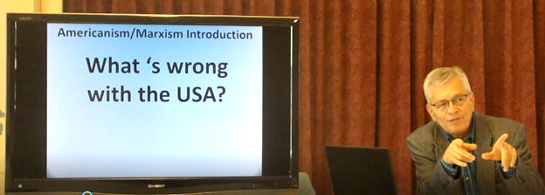
Ed Wheeler shares his Americanism and Marxism Symposium
Part 1- Americanism relies on The Judeo-Christian world view on which the United States was founded. Marxism relies on an atheistic world view that relies on human conflict to accomplish socioeconomic progress. https://www.youtube.com/watch?v=IwLFfd_U0pM

Part 2- Spiritual, intellectual and historical roots of Americanism and Marxism. https://www.youtube.com/watch?v=j8zSJvws7Wg

Part 3 Marxism invasion A: successful offense! B: failed defense!
https://youtu.be/gmdI1FVoj4k

Will you host a 2 hour AMS Prayer & Action Discussion?
- Recap Parts 1-3 Disperse notes
- Parts 4-5 Next Steps to Standing Up for the USA, for VT, and for your community
- Brainstorm next steps
- PRAY
- Local who, what, when, where - next steps
Contact amavt22@yahoo.com

Ed Wheeler shares his Americanism and Marxism Symposium
Part 1- Americanism relies on The Judeo-Christian world view on which the United States was founded. Marxism relies on an atheistic world view that relies on human conflict to accomplish socioeconomic progress. https://www.youtube.com/watch?v=IwLFfd_U0pM

Part 2- Spiritual, intellectual and historical roots of Americanism and Marxism. https://www.youtube.com/watch?v=j8zSJvws7Wg

Part 3 Marxism invasion A: successful offense! B: failed defense!
https://youtu.be/gmdI1FVoj4k

Will you host a 2 hour AMS Prayer & Action Discussion?
- Recap Parts 1-3 Disperse notes
- Parts 4-5 Next Steps to Standing Up for the USA, for VT, and for your community
- Brainstorm next steps
- PRAY
- Local who, what, when, where - next steps
Contact amavt22@yahoo.com

